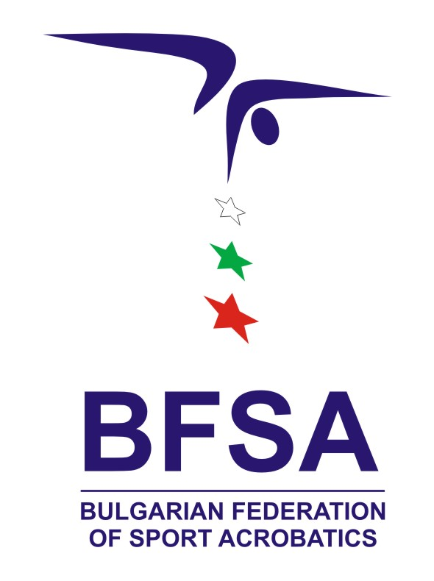
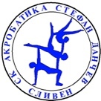

International Tournament “STEFKA SPASOVA”
Sliven, BULGARIA
29 June - 02 July, 2023

Form to be sent to: acroclubsliven@gmail.com
Organizing Committee / Host Federation
Bulgarian Federation of Sports Acrobatics
Acro Club Stefan Danchev – Sliven
Mladost Sports Hall
8800 Sliven, Bulgaria
Deadline: 20th March, 2023
ACCOMMODATION Form

Federation |  | Contact Person :
Federation |  | Phone :
Federation |  | E-mail :

Package / Hotel name | Room type  (i.e. single/double/triple/quadruple) | Arr. day | Dept. day | LAST NAME, First Name | Function | Price per  person per night | # Of nights | Total
 |  |  |  |  |  | GRAND TOTAL

Special requirements

Place and date | Seal | NF authorised signature

